Name: Class:
Introduction
Iron ores often contain a mixture of oxides and contain both Fe²⁺ and Fe³⁺ ions. The iron content of these ores may be determined by a variety of analytical techniques. This worksheet concerns three of these techniques.
PART 1: SPECTROSCOPIC ANALYSIS
The iron content of the ore sample was analysed using UV–visible spectrophotometry. The iron(III) ion, Fe³⁺, reacts with the thiocyanate ion, SCN–, to form a complex ion with an intense red colour. This complex ion may be detected in a spectrophotometer set at a wavelength of about 580 nm. A 0.100 g sample of the ore was dissolved in concentrated hydrochloric acid. The extract was filtered and treated to ensure all the iron present was converted to Fe³⁺, then 20.0 mL of potassium thiocyanate solution was added. The volume was then made up to 100.0 mL with deionised water. Four standard solutions of iron(III) were similarly treated and their absorbances measured to generate the calibration curve shown below.

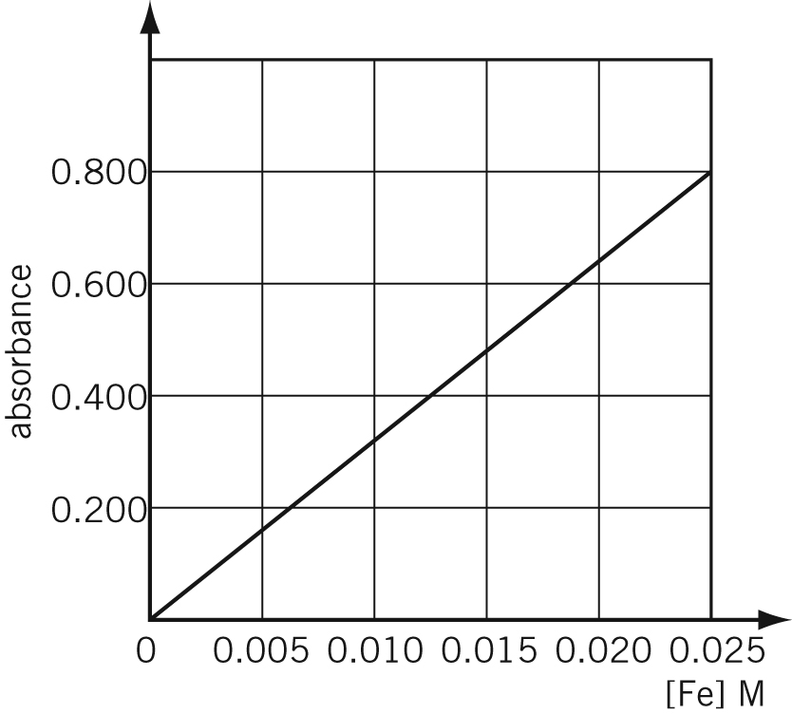

No. | Question | Answer
 | How would it have been determined that 580 nm was an appropriate wavelength for this analysis?
 | Why was it necessary to construct a calibration curve for this determination?
 | The absorbance of the iron ore solution was found to be 0.400. Calculate the percentage by mass of iron in the ore sample.

PART 2: VOLUMETRIC ANALYSIS
In a second experiment, the iron content of the ore was determined volumetrically. A 0.268 g sample of ore was dissolved in acidic solution and filtered, and the filtrate treated to convert all the iron present to Fe²⁺. This solution was titrated with a standardised, acidified 0.0335 mol L^{–1} potassium permanganate (KMnO₄) solution. The titration required 19.75 mL of the permanganate solution to reach the light pink-purple endpoint.

No. | Question | Answer
 | Write half-equations and a balanced redox equation for the titration reaction, given that the products of the titration reaction include Fe²⁺(aq) and Mn²⁺(aq).
 | Calculate the percentage by mass of iron in the ore sample, based on this volumetric analysis.
 | If some of the iron was present in the solution as Fe³⁺ prior to the titration with permanganate solution, how would this have affected the value determined for percentage of iron in the ore?

PART 3: GRAVIMETRIC ANALYSIS
In a third experiment the iron content of the ore was determined gravimetrically. A 1.01 g sample of the ore was dissolved in concentrated hydrochloric acid. The extract was filtered to remove any insoluble material. Excess sodium hydroxide solution was added, and the precipitate collected and heated to convert it to solid iron(III) oxide. 1.08 g of Fe₂O₃ was obtained.

No. | Question | Answer
Write an ionic equation for the precipitation reaction between:
a iron(II) ion and hydroxide ion
b iron(III) ion and hydroxide ion.
 | Suggest why the iron hydroxide precipitate was not simply collected, dried and weighed in this determination.
 | Calculate the percentage by mass of iron in the ore sample, based on this gravimetric analysis.
 | Suggest a possible reason why the value obtained by gravimetric analysis is significantly larger than the other determined values.

CONCLUSION
No. | Question | Answer
Which method of analysis used (spectroscopic, volumetric or gravimetric):
a is the most expensive?
b is the most prone to error?
c requires the least specialised equipment to perform?
d is likely to be the most accurate?
 | Suggest another method of analysis of the iron content of the iron ore.

